Name: Tariq Mehmood
CMSID: 023-23-0127
Section: E (BS CS)
Semester: III
Lab No: 01

Task No 1
import java.*;
import java.util.Scanner;
public class Task1Array{
public static void main(String[] args) {
Scanner sc=new Scanner(System.in);
System.out.println("Enter the size of an Array");
int size=sc.nextInt();
int A1[]=new int[size];
for(int i=0; i<A1.length; i++){
System.out.println("Enter the value No "+(i+1)+" :");
A1[i]=sc.nextInt();
}
for(int i=0; i<A1.length; i++){
System.out.print(" "+A1[i]+" ");
}
System.out.println("\n2nd Array ");
int A2[]=new int[size];
for(int i=0; i<A2.length;i++){
A2[i]=A1[--size];
}
for(int i=0; i<A1.length; i++){
System.out.print(" "+A2[i]+" ");

}
}
}
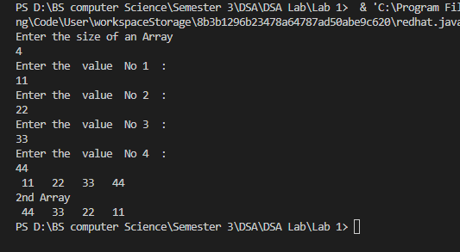

Task 02

import java.util.Scanner;
public class Task2Array{
public static void main(String[] args) {
Scanner sc=new Scanner(System.in);
System.out.println("Enter the size of 1st Array ");
int size1=sc.nextInt();
int A[]=new int[size1];
for(int i=0; i<size1;i++){
System.out.println("Enter the value No "+(i+1)+" : ");
A[i]=sc.nextInt();
}
System.out.println("Enter the size of 2nd Array ");
int size2=sc.nextInt();
int B[]=new int[size2];

for(int i=0; i<size2;i++){
System.out.println("Enter the value No "+(i+1)+" : ");
B[i]=sc.nextInt();
}
System.out.println("The Values of First Array");
for(int i=0; i<size1;i++){

System.out.print(A[i]+" ");
}
System.out.println("\n The Values of Second Array ");
for(int i=0; i<size2;i++){

System.out.print(B[i]+" ");
}
System.out.println("\nThe Values of the 3rd Array\n Combine 1st and 2nd Array");
int C[]=new int[(size1+size2)];
for(int i=0; i<size1;i++){
C[i]=A[i];
}
for(int i=0; i<size2;i++){
C[size1++]=B[i];
}
for(int i=0; i<C.length;i++){
System.out.print(C[i]+" ");
}
}
}
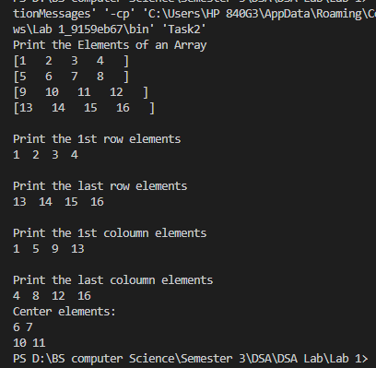
Task 3
import java.util.Arrays;
public class Task3{
public static void main(String[] args) {
int A[]={2,3,3,5,2,3,7,8,5,9,7};
Arrays.sort(A);
for(int i=0; i<A.length; i++){
System.out.print(A[i]+" ");
}
int count=0;
boolean isDuplicate=false;
for(int i=1; i<A.length; i++){
if(A[i]==A[i-1]){
if(!isDuplicate){
count++;
isDuplicate=true;
}
}
else{
isDuplicate=false;
}
}
System.out.println("\nTotal Number duplicate value: "+count);
}
}
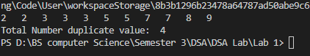
Task 04
import java.util.Arrays;

public class Task4 {
public static void main(String[] arsg) {
int[] arr = { 45, 45, 45, 60, 60, 60, 50, 50, 50, 50 };
System.out.println("Original Array");
for (int num : arr) {
System.out.print(num + " ");
}

System.out.println("\nArray after removing duplicates is:");
int[] duplicateRemoved = removeDuplicat(arr);
for (int i = 0; i < duplicateRemoved.length; i++) {
System.out.print(duplicateRemoved[i] + " ");
}

System.out.println("\nThe size of original array is: " + arr.length);
System.out.println("The size of new array is: " + duplicateRemoved.length);

}

static int[] removeDuplicat(int[] arr) {
Arrays.sort(arr);
int[] temp = new int[arr.length];

int duplicate = 0;
for (int i = 0; i < arr.length - 1; i++) {
if (arr[i] == arr[i + 1]) {
temp[duplicate++] = arr[i];

do {
i++;
} while (i < arr.length - 1 && arr[i] == arr[i + 1]);

}
}

int[] result = new int[duplicate];

for (int i = 0; i < duplicate; i++) {
result[i] = temp[i];
}

return result;
}
}
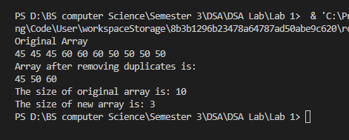
Task 05
import java.util.Arrays;

public class Task5 {
public static void main(String[] args) {

int[] arr = { 45, 45, 45, 45, 70, 45, 60, 60, 60, 50, 50, 50, 50, 80 };
System.out.print("[");
for (int i = 0; i < arr.length; i++) {
System.out.print(arr[i] + " ");
}
System.out.println("]\nThe frequency of the array is:");
frequency(arr);
}

static void frequency(int[] arr) {
Arrays.sort(arr);
int duplicate = 0;

for (int i = 0; i < arr.length; i++) {
int count = 1;

while (i < arr.length - 1 && arr[i] == arr[i + 1]) {
count++;
i++;
}

System.out.println(arr[i] + " occurred " + count + " times");

if (count > 1) {
duplicate++;
}
}

System.out.println("Total number of duplicates: " + duplicate);
}
}
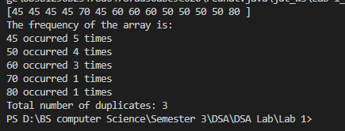

Task 06
public class Task6{
public static void main(String[] args) {
int Arr[][]={{6,2,3},{2,5,4},{5,5,1}};
System.out.println("Original Array is ");
for(int i=0; i<3; i++){
for(int j=0; j<3; j++){
System.out.print(Arr[i][j]+" ");
}
System.out.println();
}
int sumR1=0,sumR2=0,sumR3=0;

for(int i=0; i<3; i++){
sumR1+=Arr[0][i];
}
for(int i=0; i<3; i++){
sumR2+=Arr[1][i];
}
for(int i=0; i<3; i++){
sumR3+=Arr[2][i];
}
if(sumR1==sumR2&&sumR1==sumR3){
System.out.println("\nThe Array is Row Magic ");}
else{
System.out.println("\nThe Array not is Row Magic ");
}
}
}
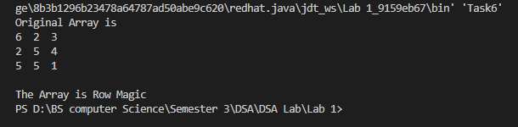
Task 07
public class Task7{
public static void main(String[] args) {
int Arr[][]={{6,0,3}, {1,5,4},{5,7,5}};
System.out.println("Original Array is ");
for(int i=0; i<3; i++){
for(int j=0; j<3; j++){
System.out.print(Arr[i][j]+" ");
}
System.out.println();
}
int sumC1=0,sumC2=0,sumC3=0;
for(int i=0; i<3; i++){
sumC1+=Arr[i][0];
}
for(int i=0; i<3; i++){
sumC2+=Arr[i][1];
}
for(int i=0; i<3; i++){
sumC3+=Arr[i][2];
}
if(sumC1==sumC2&&sumC1==sumC3){
System.out.println("\nThe Array is Coloumn Magic ");
}
else{
System.out.println("\nThe Array not is Coloumn Magic ");
}
}
}
Task 07
public class Task7{
public static void main(String[] args) {
int Arr[][]={{6,0,3},
{1,5,4},
{5,7,5}};
System.out.println("Original Array is ");
for(int i=0; i<3; i++){
for(int j=0; j<3; j++){
System.out.print(Arr[i][j]+" ");
}
System.out.println();
}
int sumC1=0,sumC2=0,sumC3=0;

for(int i=0; i<3; i++){
sumC1+=Arr[i][0];
}
for(int i=0; i<3; i++){
sumC2+=Arr[i][1];
}
for(int i=0; i<3; i++){
sumC3+=Arr[i][2];
}
if(sumC1==sumC2&&sumC1==sumC3){
System.out.println("\nThe Array is Coloumn Magic ");
}
else{
System.out.println("\nThe Array not is Coloumn Magic "); }
}
}
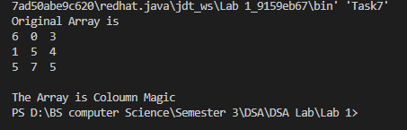
Task 8
public class Task8{
public static void main (String args[]){
int a[][]={{1,2,3},{4,5,6},{7,8,9}};
int r=3, c=3;
System.out.println("Original Array");
for(int i=0; i<r; i++){
for (int j=0; j<c; j++){
System.out.print(a[i][j]+" ");
}
System.out.println();
}
System.out.println("Vertically Flipped Array");
for(int i=r-1; i>=0; i--){
for (int j=0; j<c; j++){
System.out.print(a[i][j]+" ");
}
System.out.println();
}
}
}
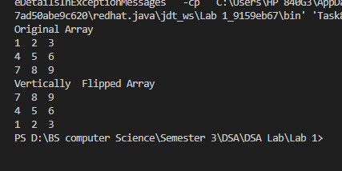

Task 9
public class Task9{
public static void main (String args[]){
int a[][]={{1,2,3},{4,5,6},{7,8,9}};
int r=3, c=3;
System.out.println("Original Array");
for(int i=0; i<r; i++){
for (int j=0; j<c; j++){
System.out.print(a[i][j]+" ");
}
System.out.println();
}
System.out.println("Horizantally Flipped Array");
for(int i=0; i<r; i++){
for (int j=c-1; j>=0; j--){
System.out.print(a[i][j]+" ");
}
System.out.println();
}
}
}
